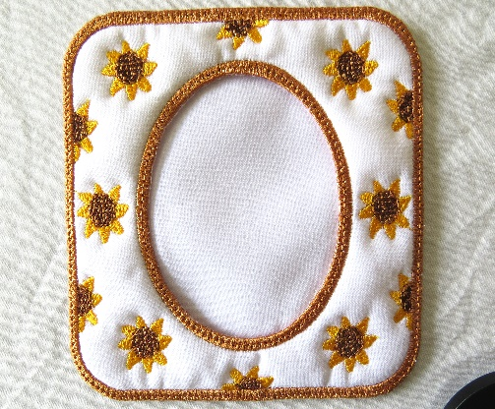In the hoop Sunflower Frame

By

Florence Clarke

Requirements for making frame.

Water Soluble Stabilizer 12 x 12 inches

5 x 7 inch hoop

Fabric for embroidery 7 x 9 inches backed with iron on pellon or similar

Back 2 pieces of fabric 7 x 9

Small ring or piece of magnet

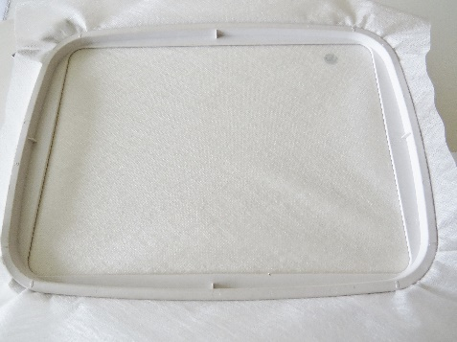Scissors to cut away fabric. I find these curved scissors are good for cutting your fabric away. 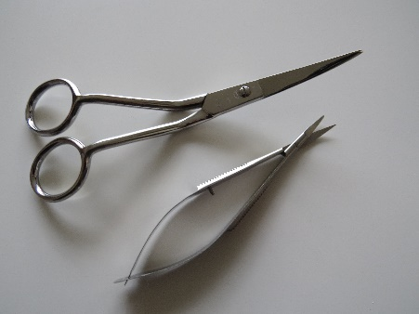

1. Hoop Water Soluble stabilizer
2. Take to machine and Sew placement line
3. Lay fabric down for embroidery and stitch tack down line 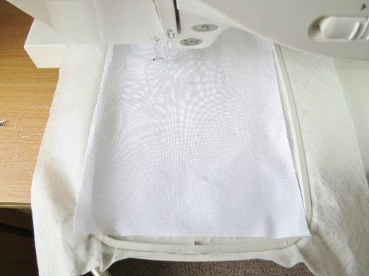
4. Complete embroidery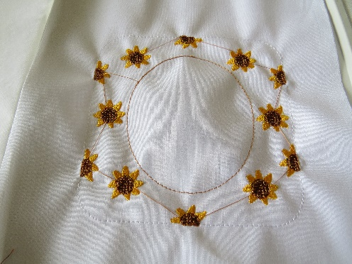
5. Remove hoop from machine but do remove fabric from hoop. Lay hoop flat on table not on your knee as the fabric could pop out of the hoop. Cut away the inner circle close to stitching as per photo. Do not cut Water Soluble Backing only remove fabric and pellon. 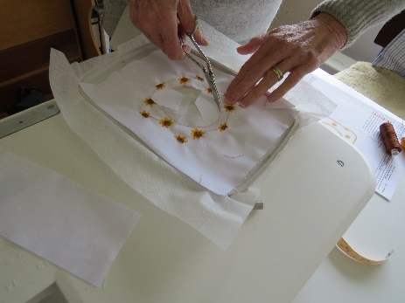 Your centre should look like this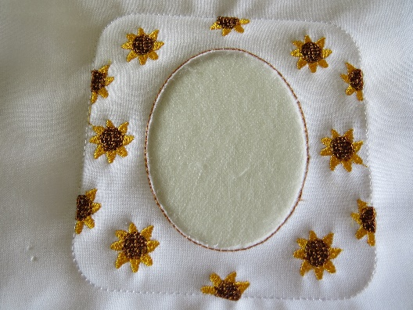
6. Return hoop to machine and complete inner circle.
7. With hoop still attached to machine carefully slide your folded backing material (wrong size facing in) under the hoop or you can remove the hoop and attach the backing fabric right side to machine with a piece of masking tape to hold it in place.
8. Stitch the tack down line then remove hoop from the machine. Do not remove fabric from hoop. Trim back to stitch line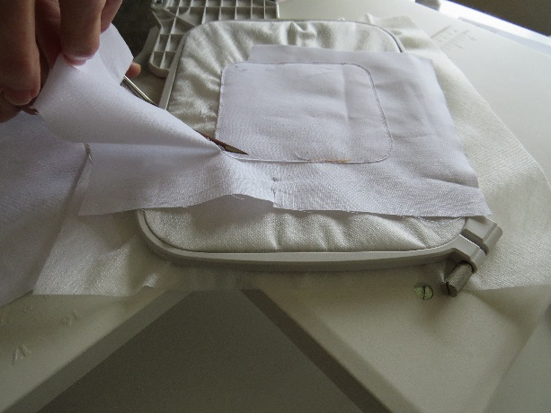 on the back and front of your work 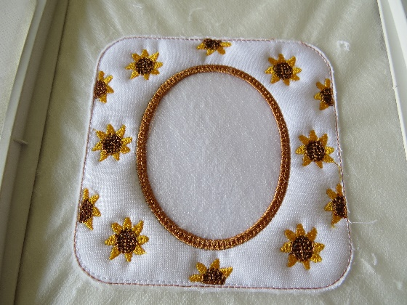
9. Return to Machine and complete final border
10. Remove hoop from machine. Now you can take your finished frame from the hoop. To remove the Water Soluble backing I used a wet cotton bud which I dabbed close to the satin border this dissolved the WSB as per 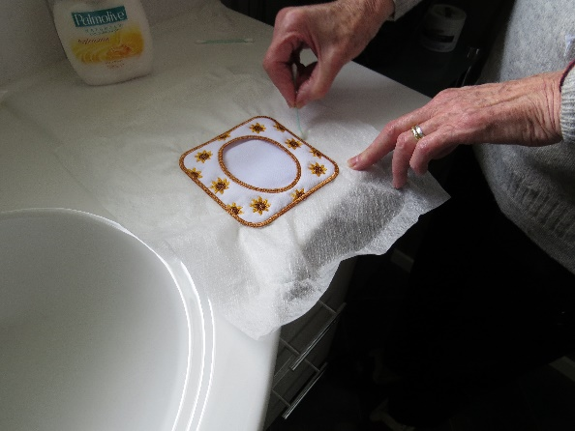 photo. To remove any little bits of WSB just carefully go round the frame with your cotton bud again this releases the bits and I used a little pair of tweezers to remove any excess.
11. To complete frame attach a small curtain or key ring to the top of the back or you may like to use a strip of magnet so you can attach your frame to the fridge. Put your favorite photo inside your frame.

Hope you enjoy making this frame as much I did.

Florence